mongoimport --type json -d uk_food -c establishments --drop --jsonArray establishments.json

NoSQL_setup_starter.ipynb

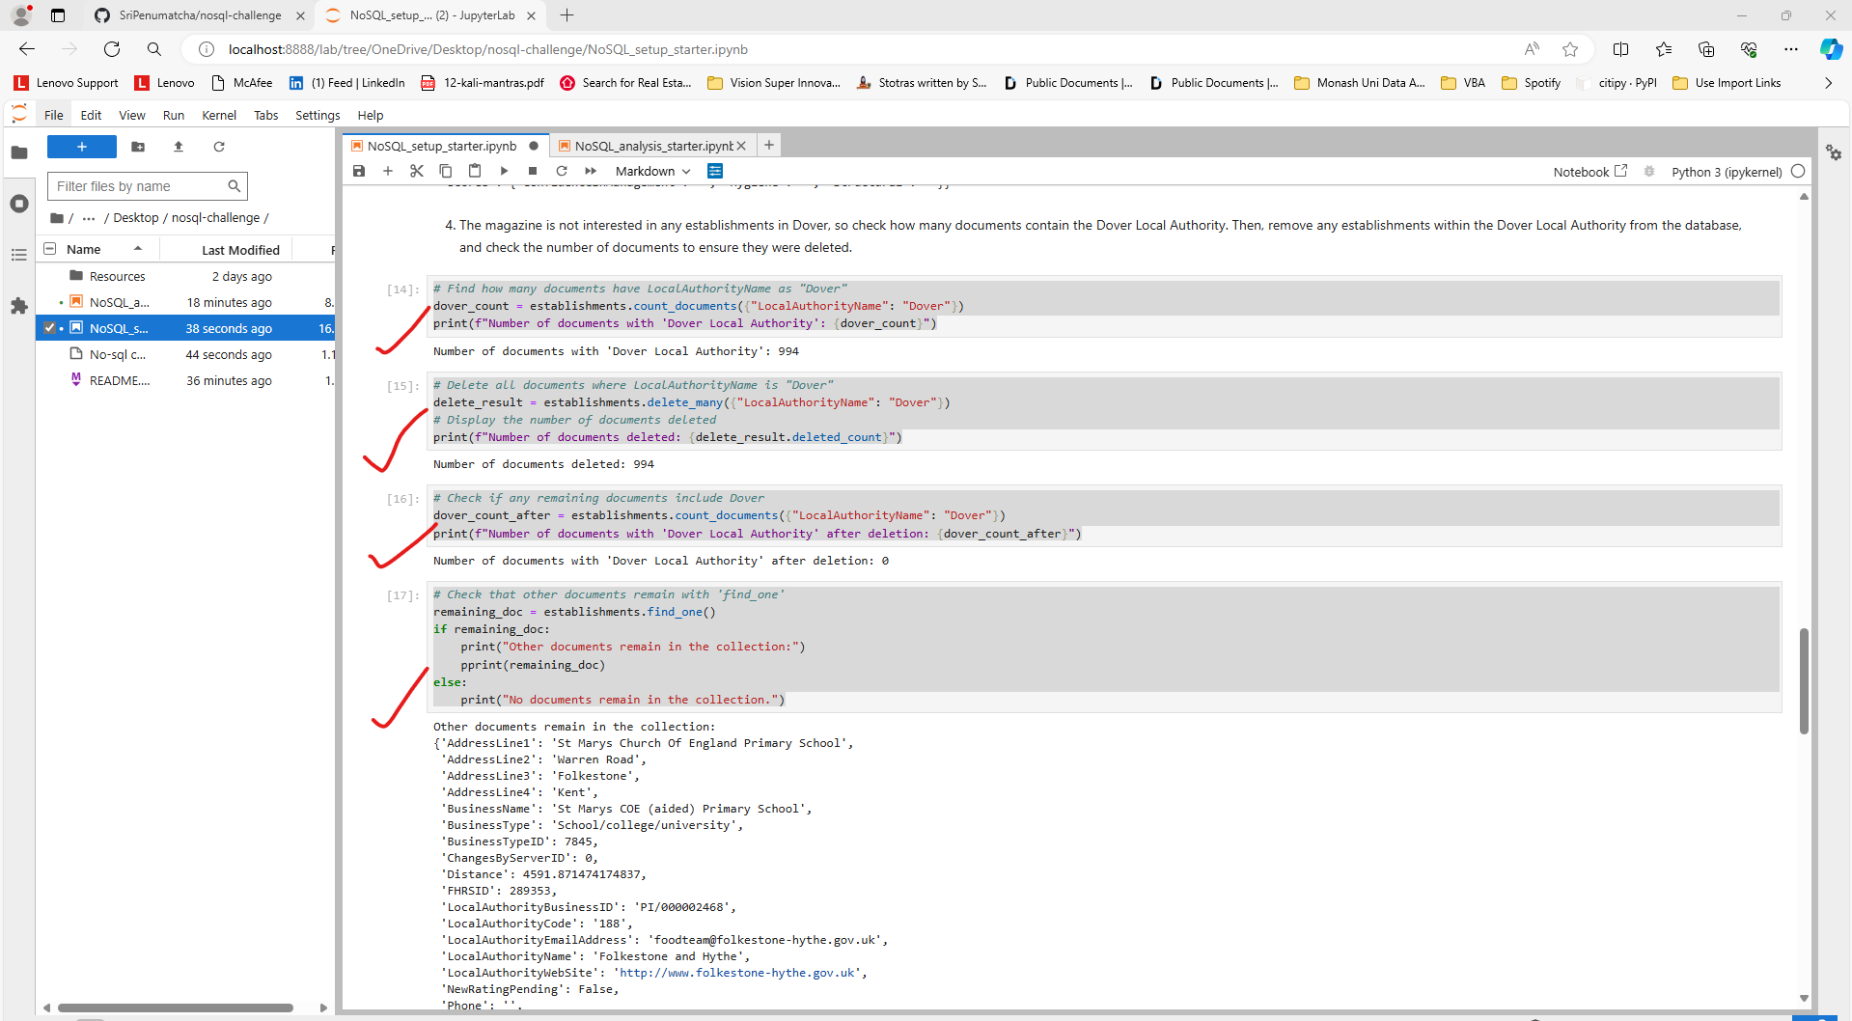

NoSQL_analysis_starter.ipynb

